**Product Name:**

SLAY

**Team Name:**

Score Flux

**Members:**

Petra Andraschko

Jatin Patel

Taylor Addington

Alegna M. Medina Rodriguez

**PITCH:**

SLAY is a top down hack and slash set in the dark medieval Queendom of Runoz where the player, assuming the role of the knight-in-training Azael, fights hordes of evil creatures, in order to defeat the big bad evil alongside your trusty animal companion.

**COMPARABLE PRODUCTS:**

**The Legend of Zelda (Original)**

Camera perspective, Map style, combat style.

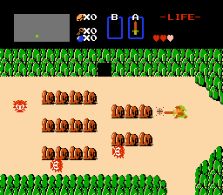

**The Binding of Isaac**

Camera perspective, combat style.

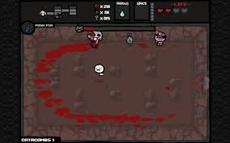

**Castlevania (Original)**

UI Design and Layout

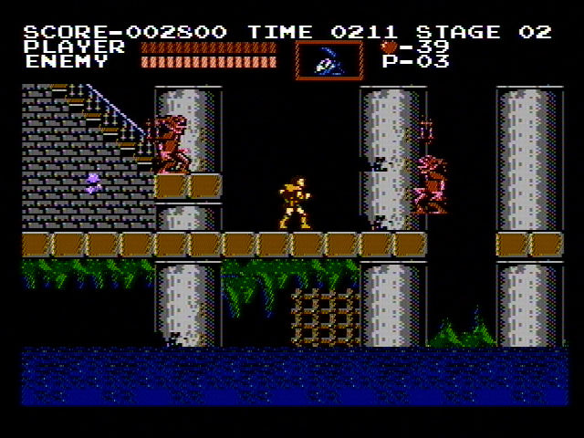

**Crawl**

Color scheme/ palette

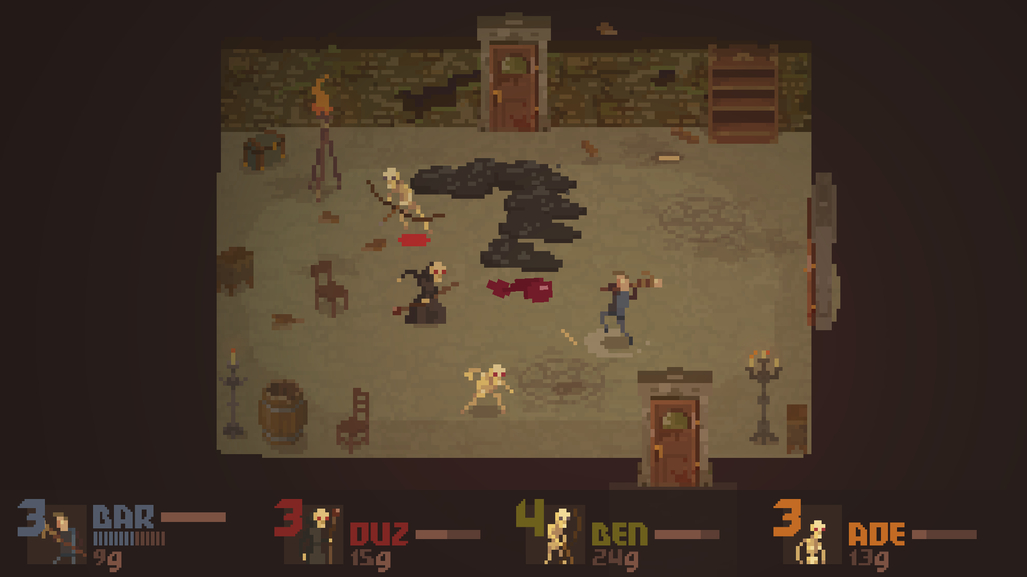

**Enter the Gungeon**

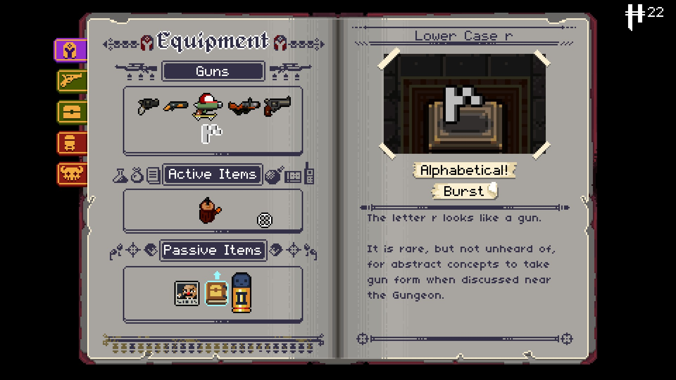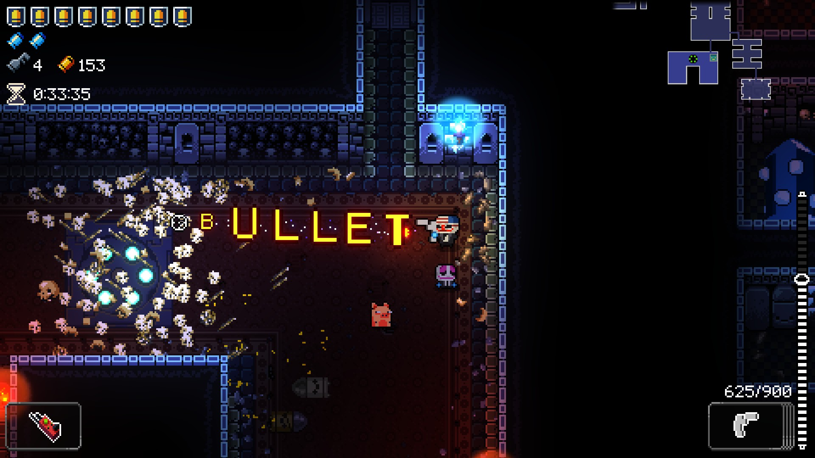

Weapon Concepts

**TYPOGRAPHY:**

Title Font



Body Font



**COLOR PALETTE:**



**#ABCC33 #8E9968 #FFE859 #9989FF #3373CC**

**IMAGE/TEXTURE GALLERY:**

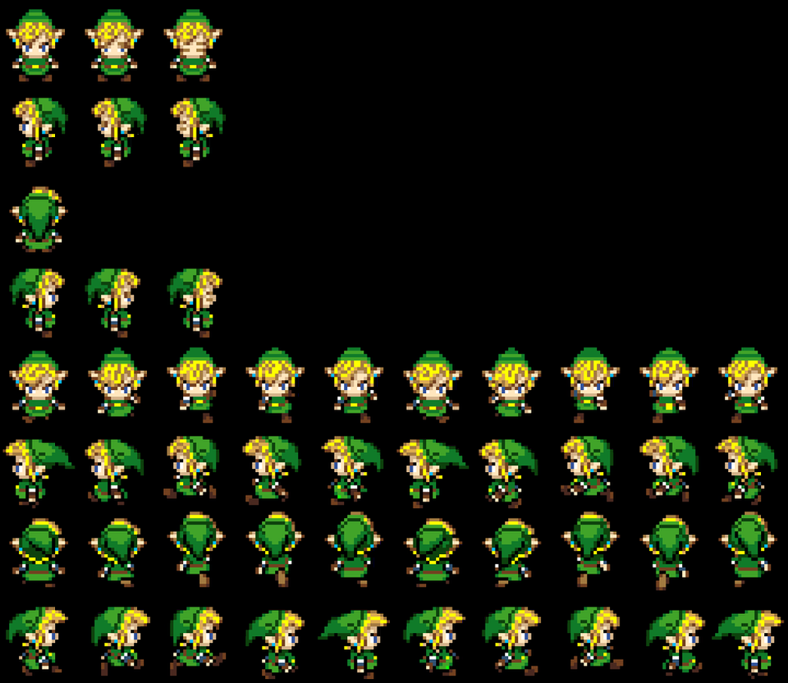 Main Character Sprite Art Reference

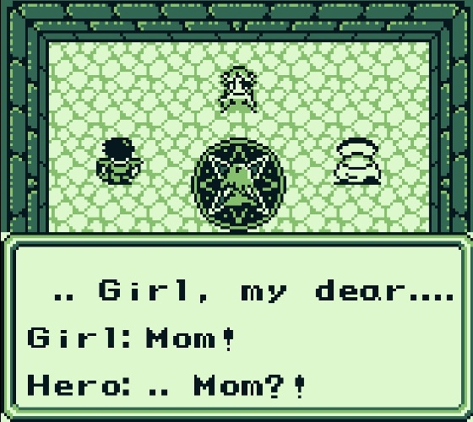 Dialogue Box Style and Location On Screen Reference

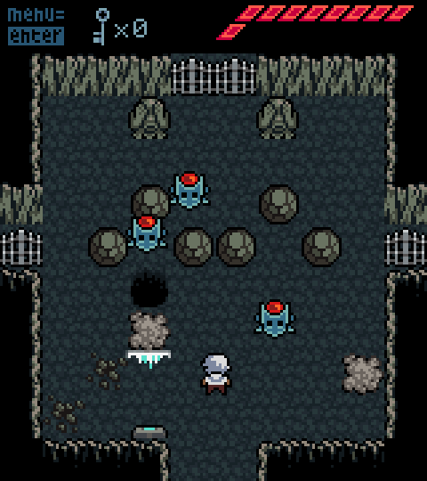 Combat Style Room Design Reference

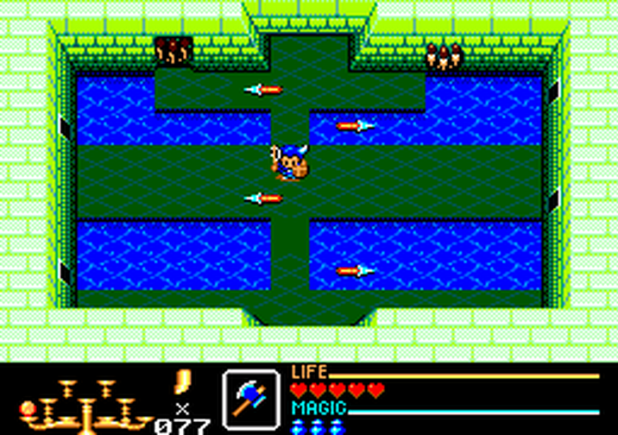 Strategy Style Room Design Reference

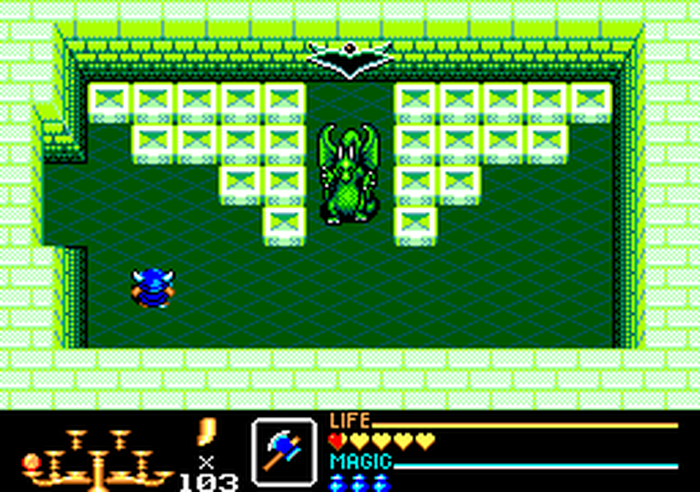 Mid Boss Room Concept Design

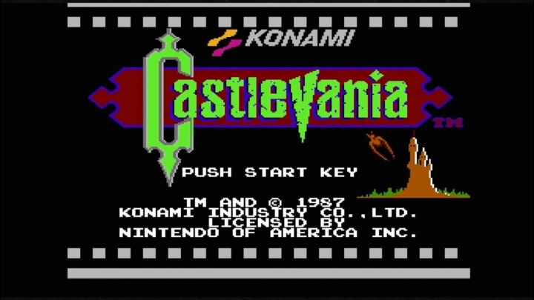Start Screen Design Inspiration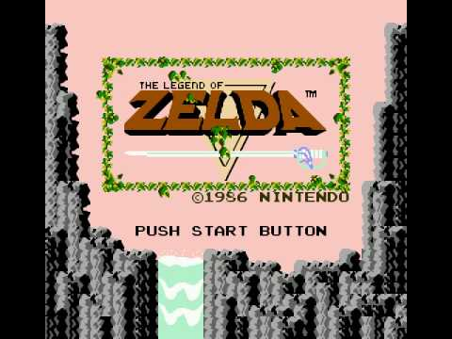

References:

ScoreFlux_Nav.jpg

ScoreFlux_UI.jpg